IHE Change Proposal

Tracking information:
IHE Domain | PCC
Change Proposal ID: | CP-PCC-XXX
Change Proposal Status: | Incoming
Date of last update: | 2013/04/29
Person assigned:

Change Proposal Summary information:
XTHM-WD fix inconsistencies and generalization
Submitter’s Name(s) and e-mail address(es): | Mauro Zanardini , Valentina Ferrarini  mzanardini@consorzioarsenal.it  vferrarini@consorzioarsenal.it
Submission Date: | 2013/04/29
Integration Profile(s) affected: | XTHM-WD
Actor(s) affected: | Consult Manager actor, Care Manager actor
IHE Technical Framework or Supplement modified: | IHE_PCC_Suppl_XTHM-WD
Volume(s) and Section(s) affected: | Vol.1 , Vol.2
Rationale for change:
To track some information on telemonitoring devices and on the installation performed at the patient’s location (e.g. if it is completed or partially performed), if they are available, we propose to add an optional document in output of the task Approve Request.
[changes in gray refer to the previous Change Proposals: CP-PCC-XTHM-WD_3]

Change Figure X.2.2 adding the box on the right.
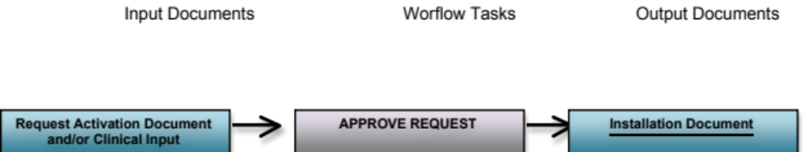

LINE 265 – Changes in Table X.2-1 Input and Output Documents of each task/status pair

Task Type | Task Status | Input Docs | Option | Output Docs | Option
Approved Request | IN_PROGRESS | Request Activation Document | R | Installation Document | O
Approved Request | IN_PROGRESS | Clinical Input | O  * These may change if Workflow Options are selected | Installation Document | O
Approved Request | COMPLETED | Request Activation Document | R | Installation Document | O
Approved Request | COMPLETED | Clinical Input | O  * These may change if Workflow Options are selected | Installation Document | O

Change in table Y.3-1

Task Type | Requirement  For task initiation | Task Statuses  *valid when task initiated | Task  Property | Input Docs | Option | Output Docs | Option
Approved Request | When Requested Activation completed | IN_PROGRESS*  COMPLETED* | Cardinality: 1..1  Removable: no | RequestActivationDocument | R | InstallationDocument | O
 |  |  |  | ClinicalInput | O  * These may change if Workflow Options are selected | InstallationDocument | O

Change in section Y.3.2

Output | None  - Optional  - InstallationDocument

Change Table Y.4-1: add Installation Document

Document Label | Example of Content Profile
InstallationDocument | XDS-SD

